TASK 2: Determination of Specific growth rate
Introduction
Experimental data describing the growth of a bacterial population X is given. A central kinetic parameter characterizing the microbial growth is the specific growth rate , which quantifies the relative biomass increase per unit time. This parameter is significant in biotechnology, as it provides insight for the state and growth dynamics of microorganisms.
The specific growth rate is defined as:
$$μ=\frac{ΔX}{Δt⋅X}≈\frac{\dot{X}}{X}$$
where $X$ denotes the biomass concentration and $t$the time.
Task 2.1:
During the exponential(logarthimic) growth phase, bacterial growth can be described by the rate of biomass increase is proportional to the current biomass. This leads to the differential equation:
$$\frac{dX}{dt}=μX$$
where $μ$is the specific growth rate and is assumed to be constant within the considered time interval.
Solving this equation yields the time-dependent biomass function:
$$X(t)=X_{0}e^{μt}$$
with $X_{0}$ representing the biomass at the initial time point $t=0$.
To estimate the “$μ$” from the given experimental data, the natural logarthim of the biomass is considered:
$$ln⁡X(t)=ln⁡X_{0}+μt$$
This transformation converts the exponential growth law into a linear relationship between $ln⁡(X)$and time. As a result, the specific growth rate $μ$can be determined as the slope of a linear regression of $ln⁡(X)$versus time.
Conclusion
Assuming the exponential growth, the specific growth rate can be easily estimated from the given data by logarithmic transformation of the biomass and linear regression. This approach provides a simple and biologically meaningful method for growth rate estimation.

Task 2.2: Estimation of the Average growth rate from experimental data
Selection of the exponential Growth phase

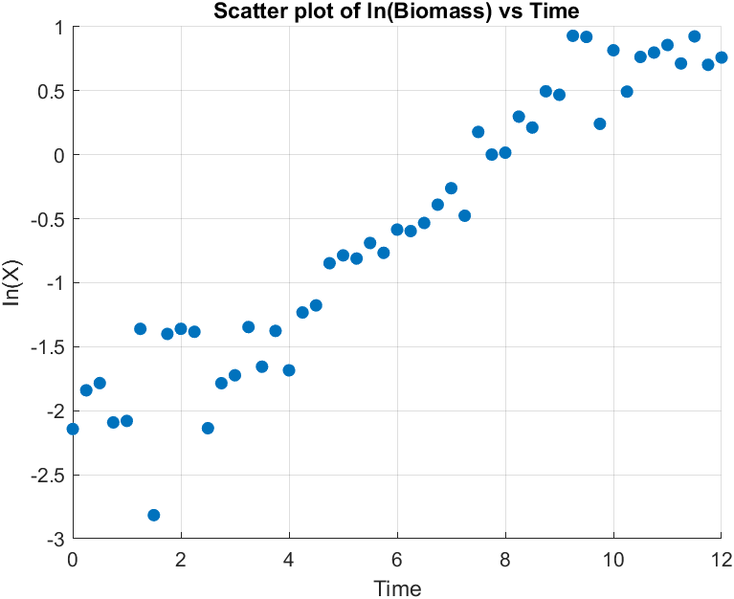
Figure 1: Scatter plot of the logarithm of biomass $ln⁡(X)$versus time for the experimental data.
From the given data, the values were plotted to identify the time interval in which exponential growth occurs. At early time, the biomass has fluctuations and doesn’t increase monotonically, indicating lag phase behaviour and some experimental noise. In contrast, between 2.75h to 9.25 h, the biomass increases rapidly and consistently, indicating the exponential growth.
Therefore, the following time window was selected for the further analysis:
$$2.75≤t≤9.75$$
Within the selected time period, the biomass data were logarithmically transformed and fitted using linear regression. According to the derivation in Task 2.1, the slope of the fitted line corresponds to the average specifi growth rate $μ$.
The regression was performed using MATLAB. The linear regression of $ln⁡(X)$versus time resulted in an average specific growth rate of:
$$\boxed{μ≈0.37{\text{h}}^{-1}}$$
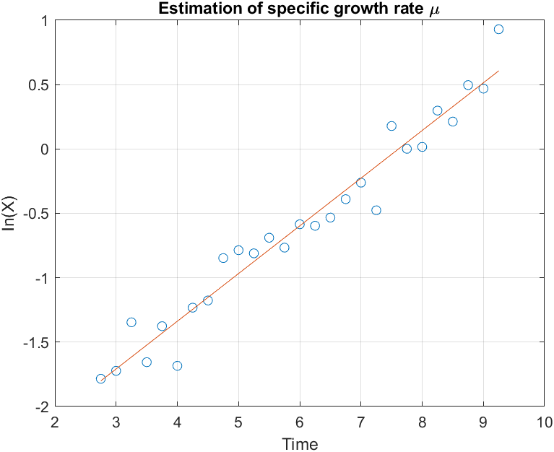
Figure 2: Estimation of the average specific growth rate $μ$
From the figure 2, the fitted regression line showed a nearly linear relationship confirming the validity of the exponential growth within the selected time interval.
Conclusion:
The estimated growth rate of approximately $0.37{\text{h}}^{-1}$indicates rapid bacterial growth, which is typical for microorganisms under favorable conditions. Minor deviations from linearlity in the logarithmic plot can indicate the experimental noise.

